Assignment-1 EEC-3150 Engineering Programming II
- In the Blackboard Resources is a LinkedIn Learning course entitled Python Essential Training.

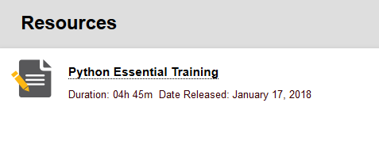
Once inside the course, you will first complete three sections of the Introduction:

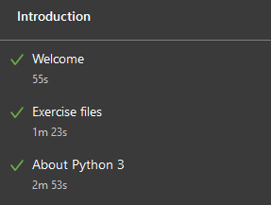

You will skip "1. Installation", but watch the first nine sections of "2. Language Overview":
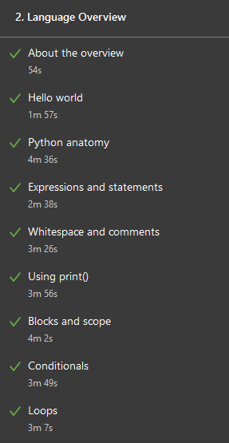

Confirm that you have watched the twelve sections by answering the question in Assignment-1-Results.docx.

NOTE: The author uses the IDE Komodo. We are using the IDE PyCharm, so references to Komodo will not apply in our environment.

- The LinkedIn Learning course references the Python script fibonacci.py in the Loops section. This script prints Fibonnaci numbers less than 1000. Change this script to calculate and display the first 20 Fibonacci numbers (regardless of their magnitude).

NOTE: You will provide both the Python script and the output from its execution.

- Modify #2 above to print the first 100 Fibonacci numbers with five per line. In other words, there will be 20 lines of output with 5 Fibonacci numbers per line.

NOTE: You will provide both the Python script and the output from its execution.
Submit: A file called Assignment-1-Results.docx to Blackboard.

